|  |  |  |  |  |
| --- | --- | --- | --- | --- |
| |  | | --- | |  | |  | |  | |  | |
| Net Economic impact: Introduction of Street Car in Downtown Cincinnati  Exploratory Data Analysis, Predictive Analysis and Forecast |
| **K. Rajesh Jagannath**  **Foundations of Data Science** Mentor: Anirban Ghosh 08/05/2016 |

Table of Contents

Net Economic impact: Introduction of Street Car in Downtown Cincinnati 1

Introduction 1

Objective 1

Motivation 1

Data Sources 2

Extraction, Transformation and Loading of Data 3

Feature Extraction 4

Exploratory Data Analysis 6

Conclusion 7

# Net Economic impact: Introduction of Street Car in Downtown Cincinnati

# Introduction

[The Cincinnati Streetcar](http://www.cincinnati-oh.gov/streetcar/design-route/) is a modern streetcar system designed to link major employment centers in downtown and uptown, connecting through Cincinnati's historic Over-the-Rhine neighborhood.

It will operate 18 hours a day, 365 days a year.

## Objective

The study’s goal is to analyze and predict the “net positive effect” on the economy in the buffer zone around the streetcar route by selecting meaningful features from various data sets.

## Motivation

The City of Cincinnati is the client. Downtown is Cincinnati’s largest employment center, with approximately 70,000 people working in the area every day. It has been proven in cities from Atlanta to Seattle that fixed rails in the ground with thousands of potential riders **draw new storefronts and businesses**, as well as **housing**. These new businesses provide employment opportunity and **boosts a city’s tax revenue.** Also, here may have been inconveniences to the neighborhood, during the construction phase.  Hence, there are two camps of opinion -

* One opinion insists that the introduction of the streetcar is disruptive to the neighborhood (crowding, transient population, noise), and
* The other opinion is that it provides easy access to business, shops, dining and commuting to work and home and draws new business, expansion of storefronts, revenue from ridership, permit fees, **property tax** and restaurant license fee.

Three buffer zones around the streetcar route were established as shown below.

* CORE: The area shown in Red color is the CORE Buffer zone. The Streetcar runs through the center of this area along a North South corridor.
* CENTER: The area shown in Magenta color is the designated CENTER Buffer zone a
* EDGE: The area shown in Green color is the EDGE Buffer zone

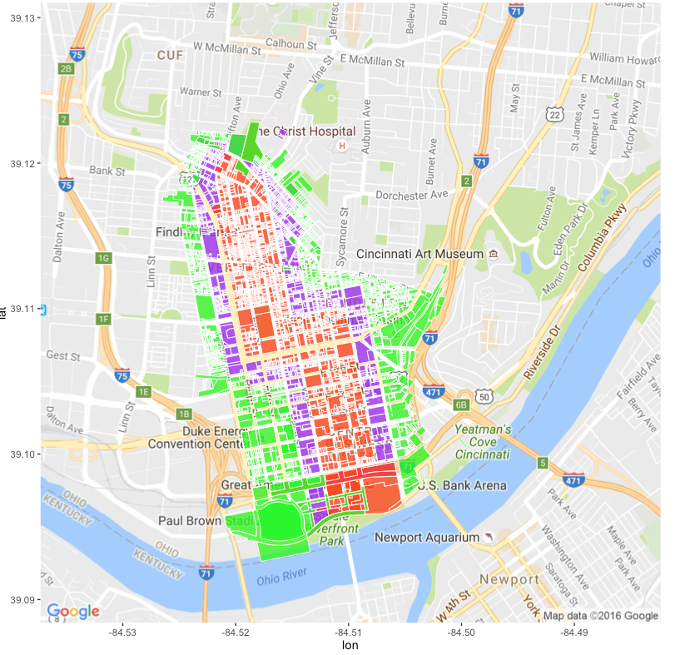

Table . ggplot of the downtown area under study illustrating the Buffer zones CORE, CENTER and EDGE around the Street Car route

Data and Sources

## Data Sources

**Data source** is [Open Data Cincinnati](https://data.cincinnati-oh.gov/) and Cincinnati Area Geographic Information Systems ([CAGIS), City of Cincinnati, OH.](http://cagismaps.hamilton-co.org/cagisportal)

1. **Buffer Area Parcels: There are three .csv files** that with an observation for each parcel in the three buffer zones under study.

* StreetCarParcels_CORE.csv
* StreetCarParcels_CENTER.csv
* StreetCarParcels_EDGE.csv

|  |  |  |
| --- | --- | --- |
| **Column name** | **Example Data** | **Description** |
| **PARCELID** | 7500010007 | Unique id to identify parcels |
| **EXLUCODE** | C | Existing Land use Code e.g. Commercial |
| **ADDRNO** | 1208 | Address, street and type of street |
| **ADDRST** | SYCAMORE |
| **ADDRSF** | ST |

**Table 2: .csv files are used to identify the parcel id. of the three areas around the Street Car - Core, Center and Edge Buffer zones**

1. **Assessors Tax Information 2007-2015: The Assessors Office**  provided data for 9 years in Fixed Width Format in 9 files.

* taxinfo2007.txt
* taxinfo2008.txt
* taxinfo2009.txt
* taxinfo2010.txt
* taxinfo2011.txt
* taxinfo2012.txt
* taxinfo2013.txt
* taxinfo2014.txt
* taxinfo2015.txt

|  |  |  |
| --- | --- | --- |
| **Column Name** | **Example Data** | **Description** |
| **PARCEL_ID** | 10001000100 | Unique id for a parcel |
|  |  |  |
| **LOC_STREET** |  | Location e.g for 2327 Sussex Ave., Cincinnati Oh |
| **LOC_HOUSE_NO** | 2327 |
| **LOC_ST_DESC** | SUSSEX |
| **LOC_ST_IND** | AV |
| **LOC_ST_DIR** |  |
| **VALID_SALE** | Y | Yes or No |
| **NUM_PARCEL** | 3 | Number of Parcels |
| **MKT_LAND_VAL** | 23000 | Value of the Land |
| **MKT_IMPR_VAL** | 140570 | Market value of the Land |
| **MKT_TOTAL** | 163570 | Mkt. Total Val |
| **ACRES** | 0.246 | Acreage of the building |
| **SALE_AMOUNT** | 116000 | Sale Amount |
| **SALE_DATE** | 20121129 | Sale date in YYYYMMDD format |
| **NEW CONSTR** | N | Newly constructed building |
| **ANNUAL_TAXES** | 3693.14 | Annual Taxes Assessed |
| **TAXES_PAID** | 3693.14 | Annual Taxes Paid |
| **DELQ_TAXES** | 6088.56 | Delinquent taxes |
| **FORECL_FLAG** | Y | Tax Foreclosure Flag |

**Table 3. Features selected from Property Tax Information from years 2007 - 2015**

# Extraction, Transformation and Loading of Data

1. **Buffer zone under study**: The three buffer-zone parcel files were in .csv format. It was read in using read_csv. Features to obtain street address and parcel id were selected. The Street address was used to geocode the data to obtain longitude and latitude of the parcel. The data was visualized for exploratory analysis. There are 900-1700 observations in each file. The file size is about 1.2 MB.
2. **Property Tax information 2007-2015**: The original datasets were provided in fixed width format. An R script converted it to .csv file. The problem here was each of the groups of years 2007, 2008 and 2009-2014 and 2015 had different column widths. The field width was clearly documented. There are 300,000 observations for each year. Files are about 150MB to 260MB in size for reach year.

# Feature Extraction

Yearly Tax Data from Years 2007-2015 is available from the Auditors office. From that data-set a few features have been identified for selection. These selections are indicative of economic growth – Market Value, Assessed taxes, Revenue from Taxes paid, Sales data , Foreclosure Data and New Construction Flag

|  |  |  |
| --- | --- | --- |
| Sl | VARIABLE | Description |
| 1 | **PARCELID** | *A Unique identifier of the parcel* |
| 2 | **LOC_STREET** | *Address for plotting on ggplot or other package to identify spatial correlation* |
| 3 | **LOC_HOUSE_NO** |  |
| 4 | **LOC_ST_DESC** |  |
| 5 | **LOC_ST_IND** |  |
| 6 | **LOC_ST_DIR** |  |
| 7 | **EXLU_CODE** | *Existing Land Use code* |
| 8 | **MKT_LAND_VAL** | *Market Value of land, Improvements, and Total* |
| 9 | **MKT_IMPR_VAL** |
| 10 | **MKT_TOTAL** |
| 12 | **ANNUAL_TAXES** | *Net Prop Tax revenue: Annual Taxes assessed, Taxes actually Paid, Delinquent Taxes and Tax Foreclosure* |
| 13 | **TAXES_ PAID** |
| 14 | **DELQ_TAXES** |
| 15 | **FORECL_FLAG** |
| 16 | **ACRE** | *Acreage to compute Property Value / sq. ft.* |
| 17 | **SALE_AMT** | *Sales data of Property : Amount, Sale Date, New Construction* |
| 18 | **VALID_SALE** |
| 19 | **SALE_DATE** |
| 20 | **NEW_CONSTR** |
|  |  |

**Table 4. There are several features available in the data set for years 2007-2015. The features in the table above have been selected and are indicators of Market value of the parcel, Annual taxes, Acre-age, Sales Data. These are representative of the net economic effect.**

|  |  |  |  |  |  |  |  |  |  |  |
| --- | --- | --- | --- | --- | --- | --- | --- | --- | --- | --- |
| **PARCELID** | **2007** | **2008** | **2009** | **2010** | **2011** | **2012** | **2013** | **2014** | **2015** | **DummyVars** |
|  |  |  |  |  |  |  |  |  |  |  |
| Over 300,000 observations/year | | | | | | | | | | |
|  |  |  |  |  |  |  |  |  |  |  |
|  |  |  |  |  |  |  |  |  |  |  |

**Table 5. Parcel id uniquely identifies an observation. Each year from 2007-2015 has a subset of features shown in Table 4. A set of Dummy variables will be used to identify CENTER, CORE and EDGE Buffer parcels. This data is not tidy data and will need to be transformed using tidyr into Table 6. Below.**

|  |  |  |  |  |  |  |  |  |  |  |
| --- | --- | --- | --- | --- | --- | --- | --- | --- | --- | --- |
| **PARCELID** | **YEAR** | **LOCATION** | **EXLU** | **MKT VALUE** | **TAXES** | **SALE** | **DUMMY VARIABLES** | | | |
|  | 2007 |  |  |  |  |  |  |  |  |  |
|  |  |  |  |  |  |  |  |  |  |  |
|  |  |  |  |  |  |  |  |  |  |  |
|  | 2007 |  |  |  |  |  |  |  |  |  |
|  | | | | | | | | | | |
|  | 2008 |  |  |  |  |  |  |  |  |  |
|  |  |  |  |  |  |  |  |  |  |  |
|  |  |  |  |  |  |  |  |  |  |  |
|  | 2008 |  |  |  |  |  |  |  |  |  |
|  | | | | | | | | | | |
|  | 2015 |  |  |  |  |  |  |  |  |  |
|  |  |  |  |  |  |  |  |  |  |  |
|  |  |  |  |  |  |  |  |  |  |  |
|  | 2015 |  |  |  |  |  |  |  |  |  |

**Table 6: The same data frame in Tidy Data Frame.**

# Exploratory Data Analysis

Plotting the position - Longitude, Latitude vs. Existing Land Use Code, vsualizes the **expected 2-D distribution** of the parcels concentrated in the CORE, CENTER and EDGE zones.

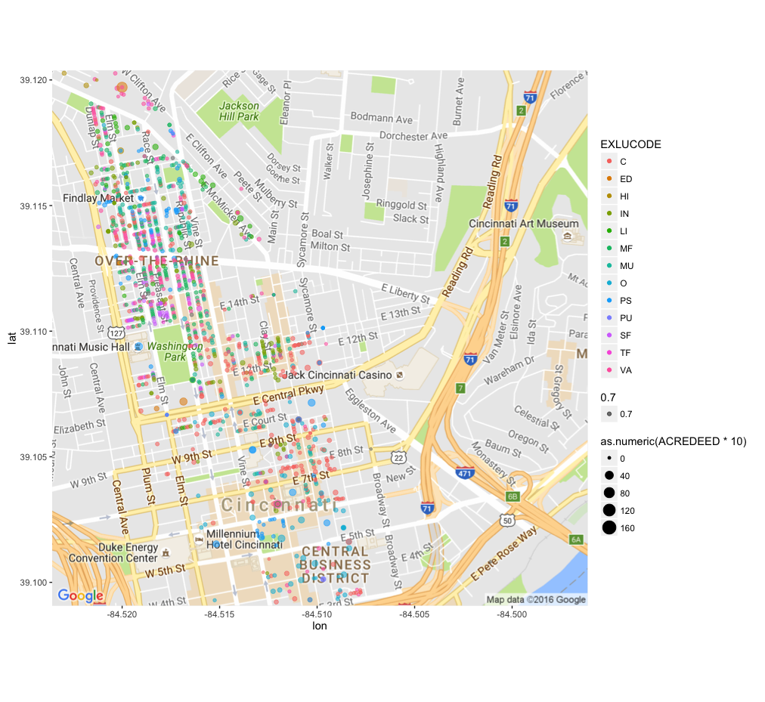

Figure . Scatterplot CORE Buffer Zone

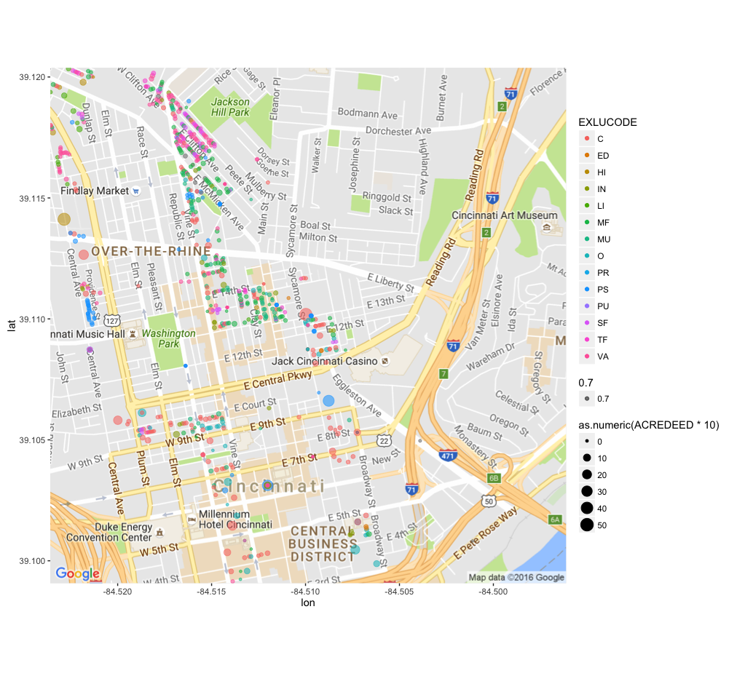

Figure . Scatterplot CENTER Buffer Zone

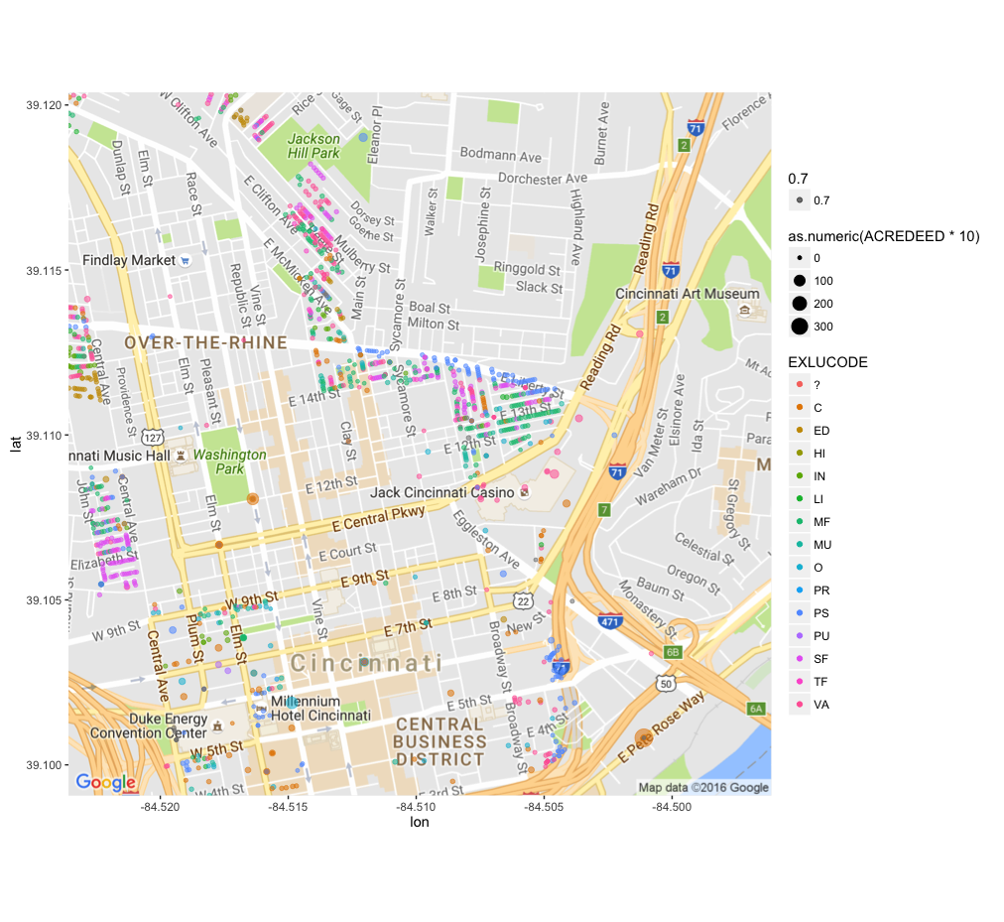

Figure . Scatterplot EDGE Buffer Zone

**Within the Buffer Zones**, we find that the distribution with respect to Existing Land Use is **not uniform**. The distribution is skewed towards Multi-family, Mixed Used, Vacant, Commercial and Public/Semi-public parcels. Also, There are too many parcels classified as vacant lots – that needs investigation.

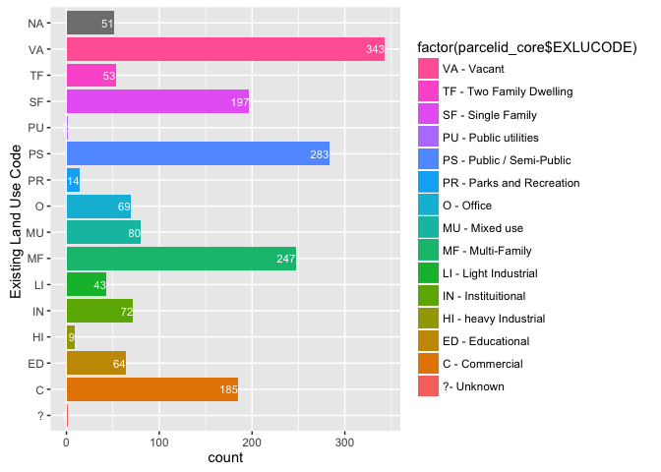

Figure . Histogram of parcels in CORE buffer zone.

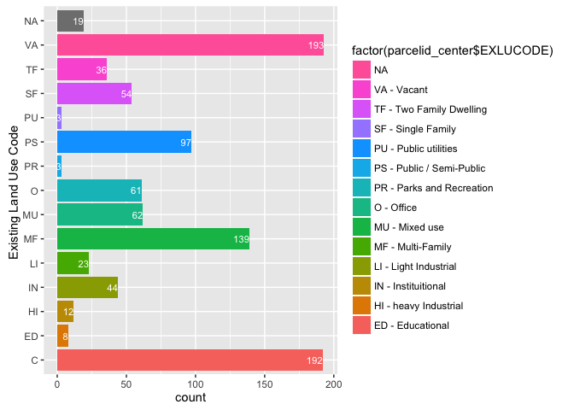

Figure . Histogram of parcels in CENTER buffer zone.

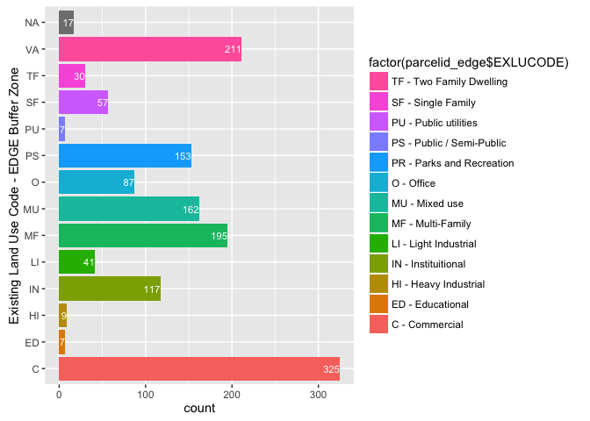

Figure . Histogram of parcels in the EDGE buffer zone

Performing 2D Kernel Density plot, we find the areas of high Market Land Value to be centered on the Buffer Zone. There **is an unanticipated concentrated distribution in the center of the Downtown** in all the three plots. This is indicative of **a problematic geocoding or the street addresses in the data are not correct**. In the scatterplot, Figure 1, Figure 2 and Figure 3, this problem is masked because the points are over-lapping each other in a single point in the center of the downtown. However, a 2-D Kernel Density Map, reveals an unusually high concentration of observations in areas not expected to be in the CENTER and EDGE buffer zones.

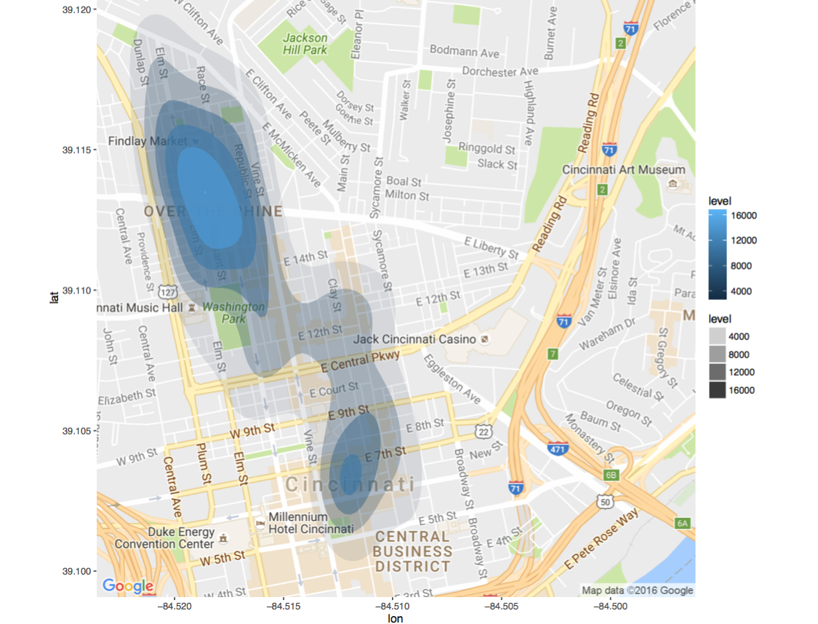

Figure . 2-D Kernel Density plot of CORE

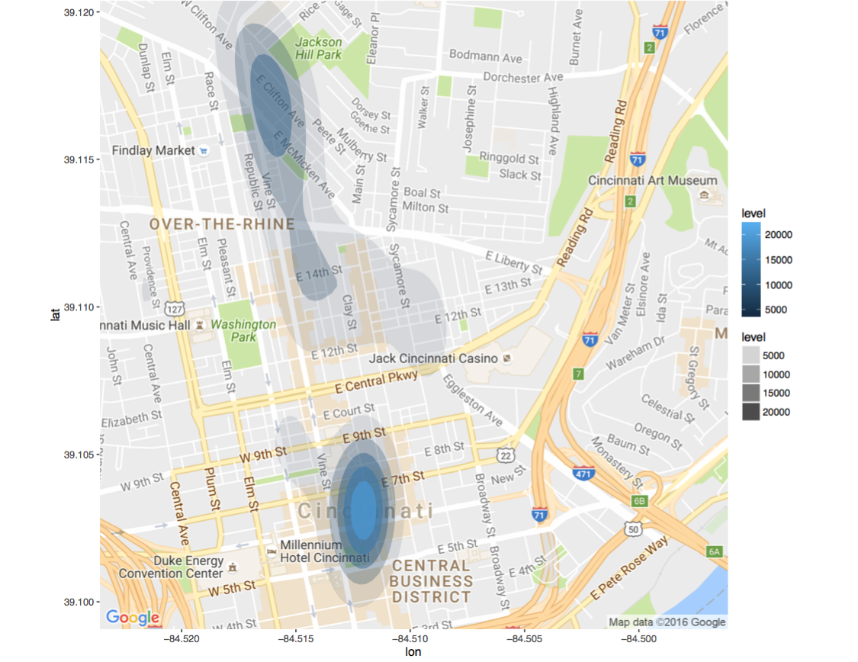

Figure . 2-D Kernel Density plot of CENTER: High density of observations near Central Business District is not expected

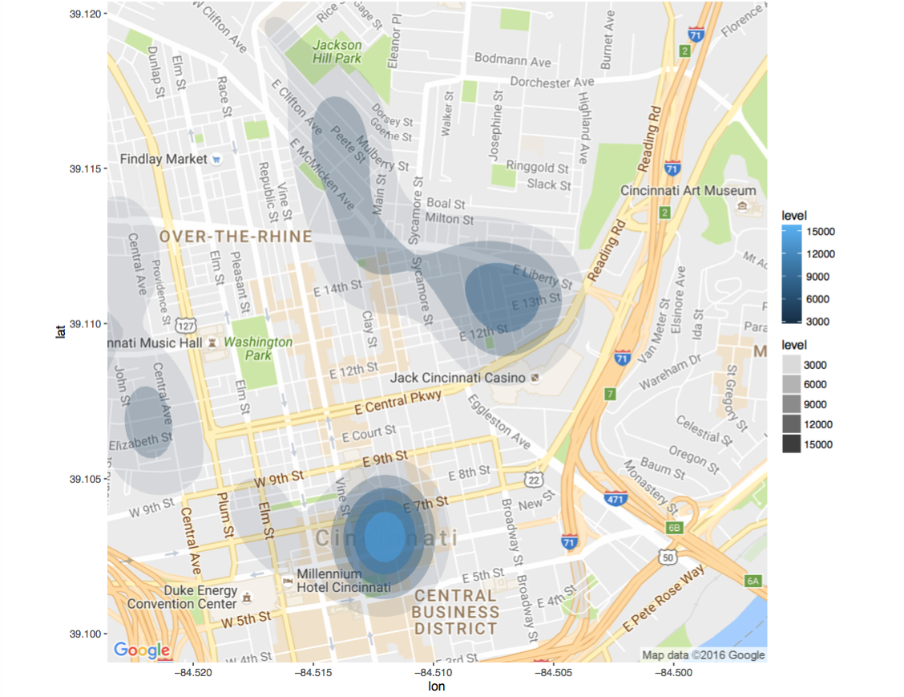

Figure . 2D Kernel Density plots of EDGE: High density of observations near Central Business District is not expected

## Conclusion

* Data 1
  + 3 csv files qualifying CORE, CENTER and EDGE buffer zone was analyzed
  + Their dimensions were 1713x8, 946x8 and 1418x8 respectively
  + Top 5 Land Use in each buffer zone were : Commercial, Multi-Family, Mixed Use, Semi-Public and Vacant
  + Parcels with 0 Market Land value were analyzed - they correspond to parcels owned by the same owner – Taxes are assessed on one parcel only for billing convenience.
  + Density map indicated some geocoded co-ordinates are not spatially situated in the buffer zones as expected. Further analysis indicated that condominium parcels are not correctly treated in the data-set provided.
  + More accurate data-set has been requested
* Data 2
  + Tax information for 9 years was provided in fixed width format and converted to csv. File size for each year’s data set is of the order of 150 MB.
  + Each year’s data set has 300000 observations.
  + 18 features indicating net positive economic effect were identified and feature extraction was performed
  + Annual Taxes was identified as dependent variable for Time series forecast
  + A data frame and its corresponding tidy-form has been proposed for future work

Bibliography

References

1. <https://dev.socrata.com/foundry/data.cincinnati-oh.gov/emnx-rw6d>
2. <http://www.cincinnati.com/story/news/2016/05/05/streetcar-nation-kc-opens-friday-cincy-next/83874740/>